**ADBMS Practical**

Practical 3: CRUD using mongoDB

**1.Creating a new database.**

**query 1.png**

**2.Creating a new collection.**

**query 2.png**

**3.Inserting document in a collection.**

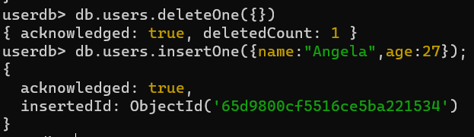

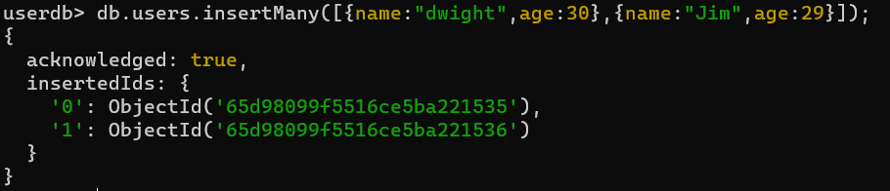

**4.Retrieve data from collection.**

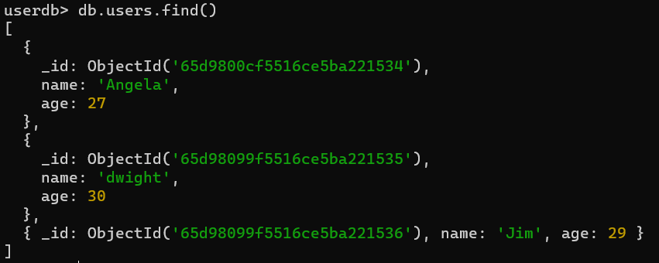

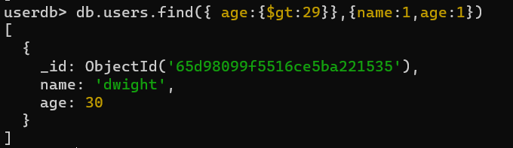

**query 7.png**

**5.Update the data**

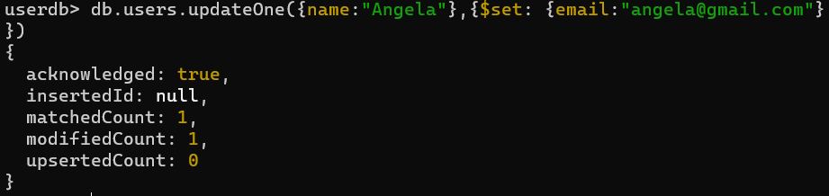

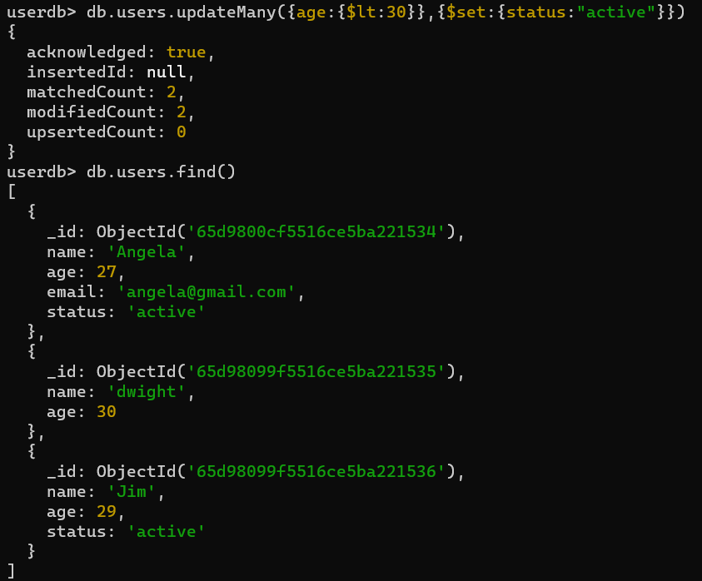

**6.Delete documents.**

**query 12.png**

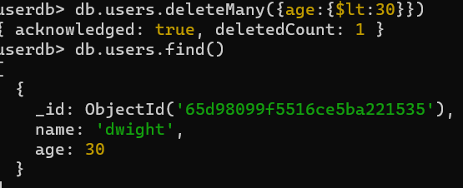

**7.Remove entire collection.**

**query 13.png**